Directions to the Collaboratory on Central at the Westward Ho Concho Room
We are located at 618 N. Central Avenue on the northwest corner of Central Avenue and Fillmore Street. These driving directions to the Collaboratory on Central at the Westward Ho will take you to visitor parking southeast of the building. Walking directions from the visitor lot to the school are below.
From Phoenix Sky Harbor Airport  - Take I-10 West to exit 145A for Seventh Street.  - Turn left (south) onto N. Seventh Street.  - Take N. Seventh Street south to E. Van Buren Street and turn right.  - Take E. Van Buren Street west to N. Central Avenue and turn right.  - Take N. Central Avenue north to E. Fillmore Street and turn right.  - Immediately take another right into the visitor parking lot (located on the southeast corner of Central and Fillmore).  From the West Valley  - Take I-10 East toward Tucson.  - Take the exit for Seventh Avenue and turn right (south).  - Take N. Seventh Avenue south to W. Van Buren Street and turn left.  - Take W. Van Buren Street east to N. Central Avenue and turn left.  - Take N. Central Ave. north to E. Fillmore Street and turn right.  - Immediately take another right into the visitor parking lot (located on the southeast corner of Central and Fillmore).  From the Northeast Valley  - Take E. Thomas Road west to N. Seventh Street and turn left (south).  - Take N. Seventh Street south to E. Van Buren Street and turn right.  - Take E. Van Buren Street west to N. Central Avenue and turn right.  - Take N. Central Avenue north to E. Fillmore Street and turn right.  - Immediately take another right into the visitor parking lot (located on the southeast corner of Central and Fillmore).  From the Southeast Valley  - Take U.S. 60 West to I-10 West toward Phoenix.  - Continue on I-10 West to exit 145A for Seventh Street.  - Turn left (south) onto N. Seventh Street.  - Take N. Seventh Street south to E. Van Buren Street and turn right.  - Take E. Van Buren Street west to Central Avenue and turn right.  - Take N. Central Avenue north to E. Fillmore Street and turn right.  - Immediately take another right into the visitor parking lot (located on the southeast corner of Central and Fillmore). | From Tucson/Southern Arizona via I-10 West  - Take I-10 West toward Phoenix to exit 145A for Seventh Street.  - Turn left (south) onto Seventh Street.  - Take N. Seventh Street south to E. Van Buren Street and turn right.  - Take E. Van Buren Street west to Central Avenue and turn right.  - Take N. Central Avenue north to E. Fillmore Street and turn right.  - Immediately take another right into the visitor parking lot (located on the southeast corner of Central and Fillmore).  From Flagstaff/Northern Arizona via I-17 South  - Take I-17 South to exit 200A to merge onto I-10 East toward Tucson.  - Take the exit for Seventh Avenue and turn right (south).  - Take N. Seventh Avenue south to W. Van Buren Street and turn left.  - Take W. Van Buren Street to N. Central Avenue and turn left.  - Take N. Central Ave. north to E. Fillmore Street and turn right.  - Immediately take another right into the visitor parking lot (located on the southeast corner of Central and Fillmore).
METRO Light Rail
Valley METRO Light Rail Web Site
Transit Schedules
Light Rail Map Description

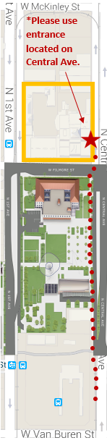
Westbound light rail directions to the Collaboratory on Central at the Westward Ho

- Stop at Central Avenue and Van Buren Street.
- Exit the train and turn right. You are now on Central Avenue facing north.
- Walk north on Central Avenue and cross on Fillmore Street.
- Continue north and entrance is located on Central Avenue.

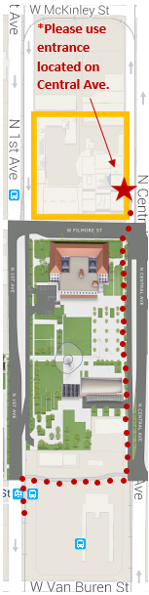
Eastbound light rail directions to the Collaboratory on Central at the Westward Ho

- Stop at 1st Avenue and Van Buren Street.
- Exit the train and turn left. You are now on 1st Avenue facing north.
- Walk north to Polk Street.
- Turn right (east) toward Central Avenue.
- Continue east and cross at Polk Street.
- Walk north and cross on Fillmore Street.
- Continue north and entrance is located on Central Avenue.

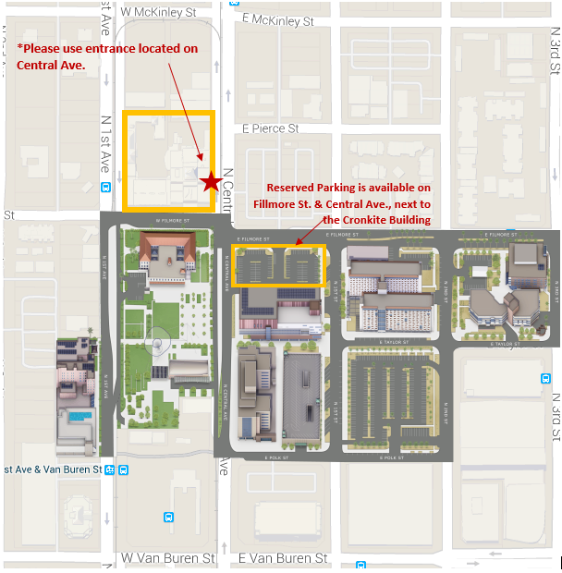
Walking directions from visitor parking to the Cronkite School

- Exit the parking lot onto Central Avenue
- Turn right (north) and walk down Central.
- Cross on Central Avenue, and turn right.
- Head north and cross Fillmore Street.
- Continue north, entrance to building in located on Central Avenue.
Alternative Parking (added this)
Parking Lot located on the northeast corner of Central Avenue and Fillmore Street.
Daily Rate: $6
Special Event: $10
Parking is valid for 12 Hours
Address
Center for Applied Behavioral Health Policy
618 N. Central Ave.
Phoenix, Ariz. 85004-0983
602.496.1470
Building Hours
Monday- Friday; between 8 a.m. and 5 p.m.
Schedule Dates

